Insulin precursor sequence conservation
Interpretation of the supplied five-species multiple sequence alignment
Across human, dog, pig, cattle, and mouse, the mature insulin chains are highly conserved, while most sequence variation and alignment gaps occur in the connecting peptide. Six cysteines are unchanged in all five sequences and correspond to the three disulfide bonds that stabilize mature insulin.

Key findings
• High conservation in the hormone: 27 of 30 B-chain columns and 18 of 21 A-chain columns are identical across all five sequences.
• More variation in precursor regions: the signal peptide has 15 of 24 identical columns; the C-peptide has 10 of 31, with gaps in seven alignment columns.
• Six invariant cysteines: alignment columns 31, 43, 95, 96, 100, and 109 are cysteine in every species.
• Processing motifs remain conserved: the two-residue basic motifs at the B/C and C/A junctions are identical in the supplied alignment.

Conservation profile
The plotted score is the fraction of the five sequences sharing the most frequent alignment character at each column. With five sequences, values change in 0.2 steps. The low points reflect substitutions and, in the C-peptide region, alignment gaps.
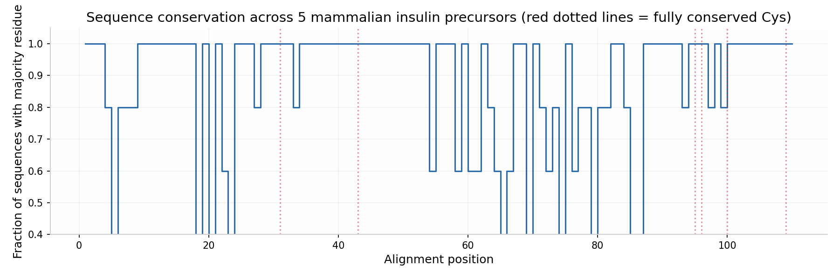
Figure 1. Supplied conservation plot. Red dotted guides mark the six fully conserved cysteine columns.

Biological interpretation
The mature B and A chains carry the strongest residue-level conservation in this alignment, consistent with constraints on insulin structure and function. The six invariant cysteines map to B7 and B19, and A6, A7, A11, and A20 in mature-insulin numbering. These form the canonical bridges B7–A7, B19–A20, and A6–A11. Their conservation supports the structural interpretation of the plot; sequence comparison alone does not measure insulin activity.
The connecting peptide is much more variable and contains the alignment’s gap positions. This pattern is consistent with greater evolutionary flexibility in the segment removed during proinsulin processing, while the basic junction motifs are retained in the supplied sequences. The signal peptide also varies more than the mature chains, though it remains largely similar across these mammals.

Data basis and limitations
The supplied alignment contains 110 columns. Its ungapped sequence lengths agree with the accompanying CSV: human 110 aa, dog 110 aa, pig 108 aa, cattle 105 aa, and mouse (Insulin-1) 108 aa. Accession identifiers listed in the CSV are P01308, P01321, P01315, P01317, and P01325, respectively.
Method provenance: the alignment text describes itself as “CLUSTAL-style” and says it used progressive Needleman–Wunsch alignment with BLOSUM-like scoring. The attachments do not establish that this is an output from a recorded Clustal Omega run, so this report interprets the provided alignment rather than independently verifying or reproducing the software workflow. Conservation counts above treat a gap as a distinct alignment character and use all five sequences in the denominator.
The comparison supports conclusions about similarity and conserved positions in these five sequences. It does not, by itself, establish the cause of each substitution, a selection history, or measured functional effects.

Conclusion
The supplied MSA shows strong conservation of the insulin A and B chains and all six cysteines associated with mature insulin’s disulfide framework. Most variation lies in the signal and connecting peptides, particularly the C-peptide. This is consistent with stronger structural constraints on the mature hormone than on the excised connecting segment.
Sources: user-provided alignment text, accession/length CSV, and conservation plot. No external sequence retrieval or independent alignment run was performed for this report.

